pl

PABALLO MARY MOKOENA

MODUDLE NAME: WED DEVELOPMENT
STUDENT NO: ST10501151
GROUP ONE
DNM0601
WEB DEVELOPMENT PROPOSAL
  - MODULE CODE: WEDE5020

Table of Contents
The proposal I have chosen to continue with is the second proposal called Pabii’s Retreat 2
First proposal 2
1.Organisation Overview 2
2. Website Goals and Objectives 3
3. Proposed Website Features and Functionality for Pabis Catering Company 3
4. Design and User Experience 3
5. Technical Requirements 4
6. Timeline and Milestones 4
8.Reference List 5
Second Proposal 7
1.Organisation Overview 7
2. Website Goals and Objectives 7
3. Proposed Website Features and Functionality for Pabii’s Retreat 8
4. Design and User Experience 8
7.Budget 11
Enquiry form 14
7. Contact Us – contact.html 15
Information to include 15
Contact form 16
Location 16
8.Reference List 17

The proposal I have chosen to continue with is the second proposal called Pabii’s Retreat

First proposal
Name: PABI’S CATERING COMPANY

1.Organisation Overview
Pabis Catering Company is a catering business/organization that provides high-quality of different cakes and catering services for different types of events and occasions. The company caters for events such as parties, weddings, Christmas celebrations, birthday celebrations, lunches, family gatherings, corporate events and other events. Pabis catering company aims to provide delicious cakes and memorable experience for its customers.
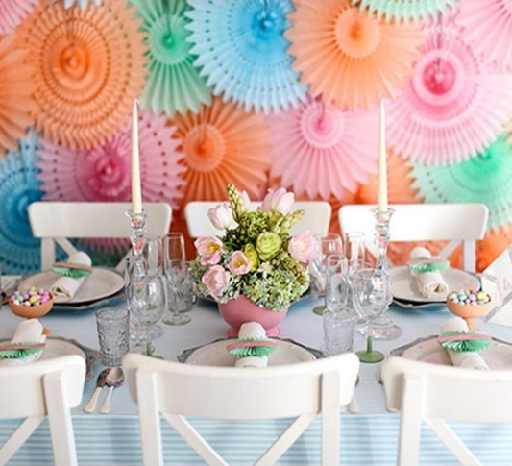
Pabis catering company focuses on preparing fresh cakes, offer different packages according to customers’
Figure 1 Pabi, created using Canva, 2026
requirements. Pabis company ensure that they maintain good hygiene standards, providing reliable services and ensuring that their customers are satisfied.
Pabis Catering Company main goal is to becomes a trusted catering service provider by delivering fresh baked cakes, excellent customer services, affordable packages, professionalism, and mostly ensure that their customers enjoy their special occasions.

Mission
Pabis Catering Company is to provide high quality, delicious cakes and affordable catering services for all the occasions that customers want to cater for themselves.
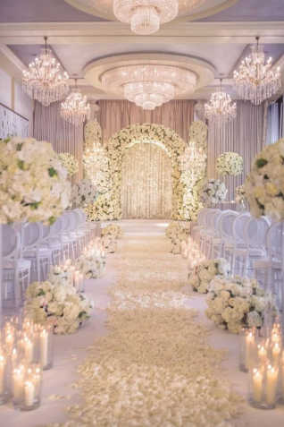
Vision
Figure 2 Pabi, created using Canva, 2026
Pabis Catering Company is to ensure that they become the most trusted and leading organisation that offers best services such as professional services, good quality, best creativity and customer satisfaction

Target audience
The business is to target all the nation with different love story that they want to tell, end with good memory and stunning setting.

2. Website Goals and Objectives
The most important goal of Pabis Catering Company website is to create a professional online presence that promotes and sell different ideas of catering by making it easier for customers to manage their budget and manage to find information easy and make the bookings. The website it helps the company to have a best communication with its customers and determines whether the website is successful

Figure 3 Pabi, created using Canva, 2026

3. Proposed Website Features and Functionality for Pabis Catering Company
The proposed of Pabis Catering company website will include a Homepage, about us, Services we offer, Package details, Gallery/Enquiry, Contact us, Customer Review, and social media integration. These features will help the company to advertise and promote its catering services, helps Pabis catering company to attract new customers, build a relationship with them and make it easier for them to have easy access to the information and to enquire about services and book catering for their events.

4. Design and User Experience
Pabis Catering Company will obtain bright, colourful and welcoming design that reflects the joyful atmosphere of weddings, parties, lunches and more special occasions. The website will have a simple navigation with the indication of a clear buttons such as “Book now” and “Get a Quote”. The proposed colour palette will include colourful colours that will be friendly, enjoyable and easy to use while assisting Pabis Catering Company to create a strong memorable brand.

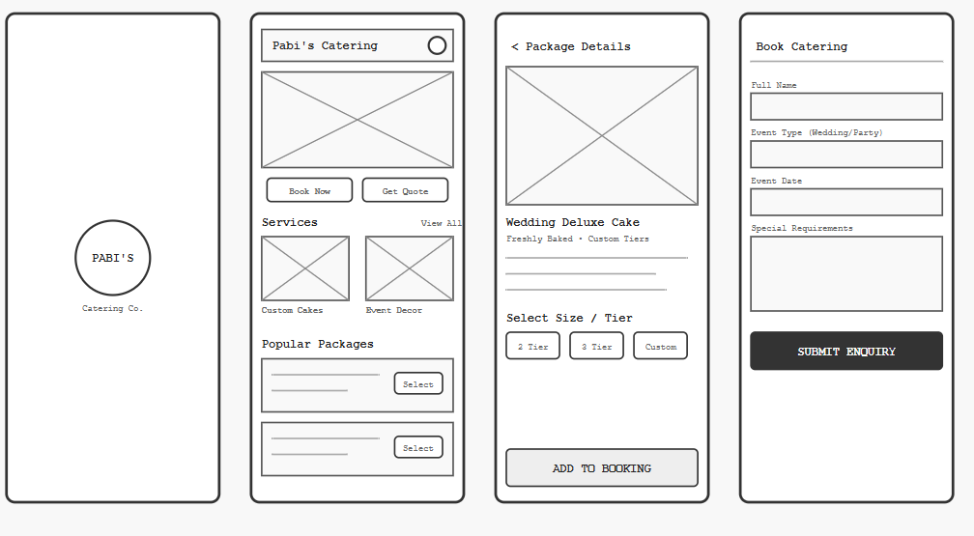Figure 4Image was created using Canva

5. Technical Requirements
Pabis Catering Company website hosts a reliable and professional website domain name that will make the company to be accessible to customers online. The website will obtain SSL certificate for security, sufficient storage for images and different ideas for cakes, regular backups and good uptime. The main programming technologies can include HTML5, CSS3 and JavaScript.

6. Timeline and Milestones
Week by Week timeline | Project Initiation and Planning
25 July 2026- 30 July 2026 | Conduct research and competitor analysis.
03 August 2026 – 21 August 2026 | Design package offering and pricing strategy.
02 September 2026 -30 September 2026 | Develop branding, homepage, and media presence.
4 October 2026 – 25 October 2026 | Collect feedback and provide enquiry page.
27 October 2026 – 06 November 2026 | Provide final project report that states finance and operational planning.

7. Budget
Activity | Estimated amounts
Research | R1000- R1500
Planning | R3500
Website Developer | R1000
Website Design | R500
Domain Registration | R1800
Testing | R700
Total budget | R8500- R10 000

8.Reference List
Happy Birthday Pretty Pink Cakes. 2025 [website]. Available at < https://www.bing.com/images/search?view=detailV2&ccid=TbGMdFgl&id=0CA73BA45EAE336DECBFD1CC014C3403A0D73EB5&thid=OIP.TbGMdFglcoD92DVC27hJAgHaHa&mediaurl=https%3A%2F%2Fqualitycakecompany.com%2Fwp-content%2Fuploads%2F2022%2F12%2Fpretty-pink-floral-dots-1024x1024.jpg&cdnurl=https%3A%2F%2Fth.bing.com%2Fth%2Fid%2FR.4db18c7458257280fdd83542dbb84902%3Frik%3DtT7XoAM0TAHM0Q%26pid%3DImgRaw%26r%3D0&exph=1024&expw=1024&q=birthday+cakes&ck=E4DB8B6A6B6E6D0370E5C5414E8C1F9C&selectedindex=93&itb=0&ajaxhist=0&ajaxserp=0&vt=0&sim=11&shtc=0&shth=OIP.TbGMdFglcoD92DVC27hJAgHaHa&shsc=idp&form=EX0050&shid=07927f23-25ae-4351-9b25-b16b44c899ce&shtp=GetUrl&shtk=SGFwcHkgQmlydGhkYXkgUHJldHR5IFBpbmsgQ2FrZXM%3D&shdk=Rm91bmQgb24gQmluZyBmcm9tIGZpdHkuY2x1Yg%3D%3D&shhk=hwf4kiRYGtKM7RHDq6Ra2w9ZDLOqbbI0lhYhDrtQrdA%3D > [Accessed 27 July 2026].
How to write the company overview for a business plan. 2026. [website]. Available at < https://www.liveplan.com/blog/planning/company-overview > [Accessed: 25 July 2026].
Mission and Vision statements for new businesses. 2024. [website]. Available at < Mission and Vision Statements for New Businesses: 19+ Examples - Business Planner® > [Accessed: 25 July 2026].
Party decorating a room for a party idea to impress your guests. 2025. [website]. Available at < https://www.bing.com/images/search?view=detailV2&ccid=nP0H04eJ&id=85E389B23BC56A1B13F2D732B02E3671C3C58B17&thid=OIP.nP0H04eJCrh-q9pGHULiKQHaGK&mediaurl=https%3A%2F%2Fglobal-uploads.webflow.com%2F61d11361f2619188818de7ca%2F624fa4450c90da27761a9f7f_decorating.jpg&cdnurl=https%3A%2F%2Fth.bing.com%2Fth%2Fid%2FR.9cfd07d387890ab87eabda461d42e229%3Frik%3DF4vFw3E2LrAy1w%26pid%3DImgRaw%26r%3D0&exph=1066&expw=1280&q=party+decorations&ck=CF8A42FBE2CED49E0DA4ED97724620A8&selectedIndex=10&itb=0&ajaxhist=0&ajaxserp=0&shtc=0&shth=OIP.nP0H04eJCrh-q9pGHULiKQHaGK&shsc=idp&form=EX0050&shid=2ac79452-2714-4df9-b489-5844234286ed&shtp=GetUrl&shtk=UGFydHkgZGVjb3JhdGluZyBhIHJvb20gZm9yIGEgcGFydHkgaWRlYXMgdG8gaW1wcmVzcyB5b3VyIGd1ZXN0cw%3D%3D&shdk=Rm91bmQgb24gQmluZyBmcm9tIGdsb2JhbC11cGxvYWRzLndlYmZsb3cuY29t&shhk=JJScRBXhVRUxxAI7%2BVVmiav73kfVyqX6HAC7MOGjy3E%3D > [Accessed: 27 July 2026]
Wedding party decorations 2024. [website]. Available at < https://www.bing.com/images/search?q=Wedding+Party+Decorations&form=RESTAB&first=1> [Accessed 27 July 2026].

Second Proposal

Pabii’s Retreat
Figure 5 Pabi, created using Canva, 2026

1.Organisation Overview
Pabii Massage Parlour Wellness Sanctuary wad founded by Paballo in July 2026, was created and dedicated with the vision of helping clients to restore their balance, relieve stress and improve their overall health. It was established to deliver the needs of clients after the recognition that a lot of people suffer from stress, fatigue, muscle tension and the pressure of life. The massage parlour will ensure that it offers different range of therapeutic services that will includes hot stone therapy, facial treatment, Swedish massage, full body massage and more.
Main reason of establishing Pabii’s Retreat was to provide affordable, high-quality services to motivate people to prioritise their health, promote their physical and mental wellness in a calm and comfortable environment.
Mission Statement
We aim to provide exceptional and personalised therapy that calms the mind, relax the body, lift the spirit and mostly creating a lasting sense of well-being to our clients.
Target audience
The business target clients that need to step away from the reality a bit and have a deep rest that is full of recharging and reconnecting of soul and regaining of new energy. Pabii’s Retreat doesn’t have target age but accepts everyone.
Vision Statement
Our aim is to become a respected, leading and reputable centre of excellence by providing clinically rehabilitation centre
Key Performance Indicators (KPIs)
- Pabii’s Retreat doesn’t have a current website yet, therefore the KPIs of the company have not yet been measured.
- After the launch of the website the KPIs of the organisation will be monitored by determination of customer engagement.
- The success of the website will be monitored by customer service enquires, bookings and providing feedback/review about the Retreat.


Figure 6 Pabi, taken by my phone, 2026

2. Website Goals and Objectives
- The most important goal of Pabii Retreat website is to create a professional online presence that promotes and offer different retreats making it easier for customers to manage their budget and manage to find information easy and make the bookings.
- The website it helps the company to have a best communication with its customers, offer loyalty programs and determines whether the website is successful.

3. Current Website Analysis (No current website)
Weakness
- Strong competition of same company.
- Building a customer relationship.
- Not enough experience.
Improvements
- Creating social media marketing and do promotion by offering special opening packages for groups.
- Ensure to provide unique therapeutic packages.
- Get more training and seek business advise.
- Monitor customer’s feedback

4. Proposed Website Features and Functionality for Pabii’s Retreat
- The proposed of Pabii’s Retreat website will include a Homepage, about us, Services we offer, Package details, Gallery/Enquiry, Contact us, Customer Review, and social media integration.
- These features will help the company to advertise and promote its services, helps Pabii’s Retreat to attract new customers, build a relationship with them and make it easier for them to have easy access to the information and to enquire about their services and book spa dates.
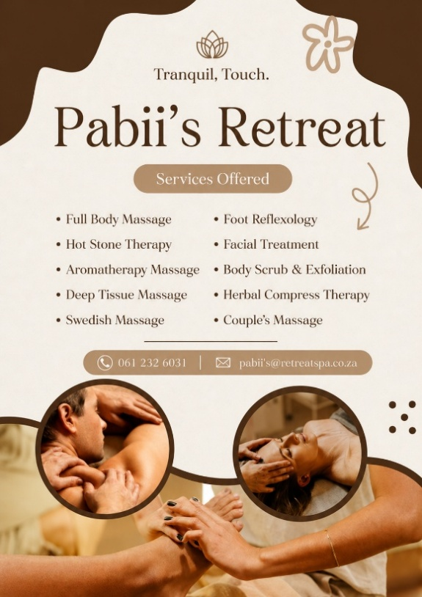
Figure 7: image was created using Canva

5. Design and User Experience
- Pabii’s retreat company will obtain nude and welcoming design that reflects the joyful atmosphere of reconnecting, regrouping, relaxing and refreshing.
- The website will have a simple navigation with the indication of a clear buttons such as “book now” and “get a quote”.
- Typography: The Pabii’s Retreat website will use Arial for main headings and Aptos for body. This combination will represent professional.

Colour Palette



Figure 8 Pabi, created by Canva, 2026

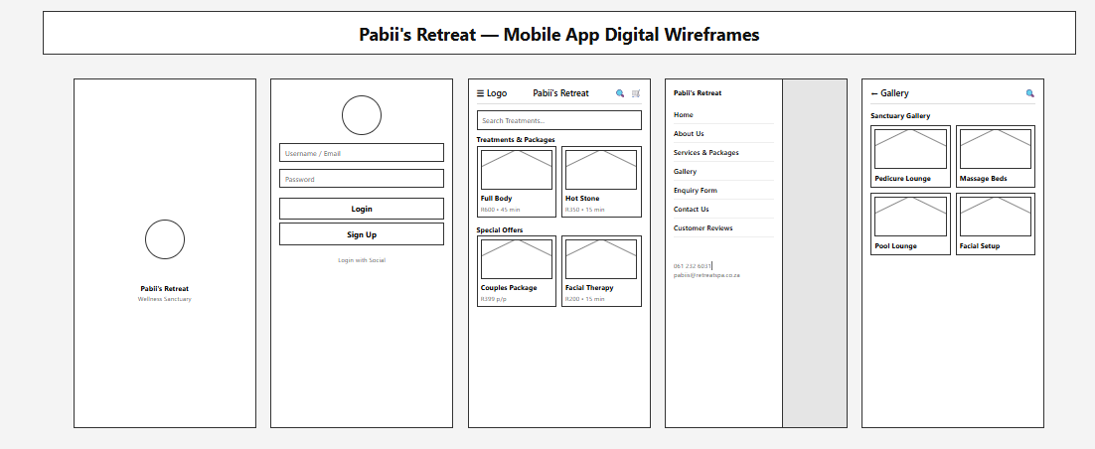

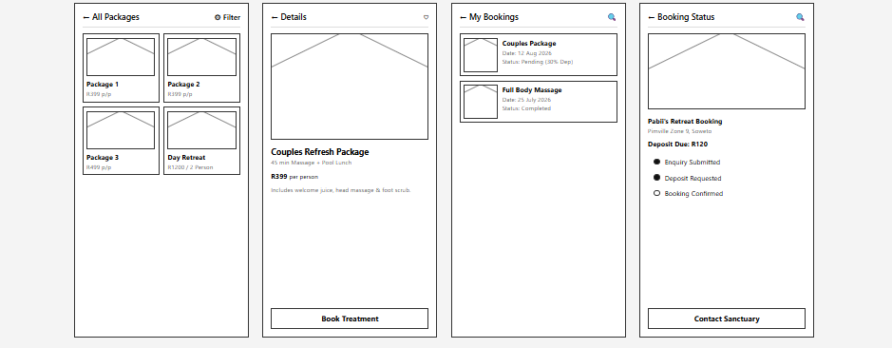
Figure 9Image was created using Canva
6. Technical Requirements
- Pabii’s Retreat website hosts a reliable and professional website domain name that will make the company to be accessible to customers online.
- The website will obtain SSL certificate for security, sufficient storage for images and different ideas for cakes, regular backups and good uptime.

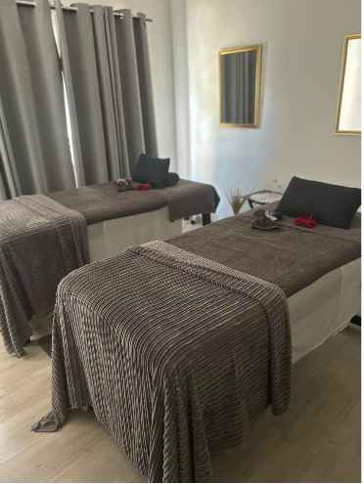
- The main programming technologies can include HTML5, CSS3 and JavaScript.
Figure 10 Pabi, taken by phone
Figure 11 Pabi, taken by phone

7. Timeline and Milestones

Week by Week timeline | Project Initiation and Planning
25 July 2026- 27 July 2026 | Establish Pabii’s Retreat concept and define objectives, goals and target market.
10 August 2026- 21 August 2026 | Conduct research and competitor analysis.
23 August 2026- 07 September 2026 | Develop business design package offering and pricing strategy.
10 September 2026- 22 September 2026 | Develop Pabii’s branding, homepage, logos, colour scheme and media presence.
25 September2026- 04 October 2026 | Collect feedback from potential users, test the website and provide enquiry page.
08 October 2026- 23 October 2026 | Launch website, collect feedback and monitor KPIs.
26 October 2026- 06 November 2026 | Provide final project report that states finance and operational planning.

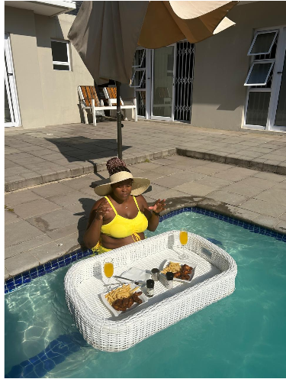
Figure 12 Pabi, taken by phone

8.Budget
Activity | Estimated amounts
Research | R800- R1000
Planning | R1500
Website Developer | R1200
Website Design | R500
Domain Registration and hosting | R1800
Images | R 500- R2000
Testing | R600
Total budget | R6 900- R8 600

8.Reference List
How to write the company overview for a business plan. 2026. [website]. Available at < https://www.liveplan.com/blog/planning/company-overview > [Accessed: 25 July 2026].
Mission and Vision statements for new businesses. 2024. [website]. Available at < Mission and Vision Statements for New Businesses: 19+ Examples - Business Planner® > [Accessed: 25 July 2026].
Same content of picture, they are my personal picture that I took when I was visiting one of the spa places in Highlands North. Author P Mokoena
Shopify. 2025. A Step-by-Step Guide to Writing a Spa Business Plan. Online. Available at: https://www.shopify.com/au/blog/spa-business-plan [Accessed 25 July 2026].

